Appendix 1: Validations since March.2017

|  |  |  |  |  |
| --- | --- | --- | --- | --- |
| **Error Number** | **Error Message** | **Reject Record** | **Description** | **Remediation** |
| 320 | Invalid Type of Transplant | Y | Type of transplant: must be one of the values Auto, Allo R, Allo U, Haplo. Ignore if Photopheresis_Treatments is not null | Select type of tranplant |
| 331 | Date must be after the initial diagnosis (for Allo-R) or after HLA typing (for Allo-U and HAPLO) and before transplant date | Y | If type of transplant is **Allo-R** then  Date of match found must be after the date of initial diagnosis and before the date of transplant.  If type of transplant is **Allo-U or HAPLO** then  Date of match found must be after the date of HLA typing and before the date of transplant.  Ignore Validation if Null  Ignore validation if date of HLA typing is null  Ignore if Photopheresis_Treatments is not null | Enter a date that is after the initial diagnosis for Allo-R or after HLA typing for Allo-U and HAPLo and before transplant date |
| 338 | Invalid date of first induction - Type of transplant must be Allo-R or Allo-U or Haplo | Y | Date of First Induction : If this date is present, the type of transplant must be one of Allo-R or Allo-U or Haplo.  Ignore validation if null  Ignore validation if Photopheresis_Treatments is not null | Select Allo-R or Allo-U or Haplo as the type of tranplant |
| 339 | Invalid date of first re-induction - Type of transplant must be Allo-R or Allo-U or Haplo | Y | Date of First Re-induction: If this date is present, the type of transplant must be one of Allo-R or Allo-U or Haplo.  Ignore validation if null  Ignore validation if Photopheresis_Treatments is not null | Select Allo-R or Allo-U or Haplo as the type of tranplant |
| 609 | When Type_Transplant is Allo-R or Allo-U or Haplo, and Canceled_Flag is 'No', Ready_to_Transplant_Date must have a value | Y | Type_Transplant is (Allo-R or Allo-U or Haplo) **and** Canceled_Flag is 'No' **and** (and Post_Transplant_Receiving_Centre_Submission is not ‘Yes’) **and** Ready_to_Transplant_Date is Null | Enter a ready to transplant date |
| 610 | Ready_to_Transplant_Date must be before Transplant Date | Y | Ready_to_Transplant_Date is not Null and Date_Transplant is not Null and Ready_to_Transplant_Date > Date_Transplant | Enter a ready to transplant date that is before the transplant date |
| 619 | The dose value must be within the allowed range for this drug | Y | If does value is greater than the specified upper range for Carmustine (700mg) and/or thiotepa (2000mg), display error msg | Enter a dose that is lower than the upper does limit for Carmustine and thiotepa |

# Appendix 2: Facility Numbers[1]

|  |  |  |  |
| --- | --- | --- | --- |
| **#** | **Program Title** | **Submitting Hospital** | **Facility Number** |
| 1 | Stem Cell Transplant | Kingston General Hospital | 693 |
| Mt. Sinai Hospital | 842 |
| Grand River Hospital Corp | 930 |
| Windsor Regional Hospital | 933 |
| Thunder Bay Regional Health Sciences Centre | 935 |
| London Health Sciences | 936 |
| Hamilton Health Sciences Corporation | 942 |
| University Health Network | 947 |
| Lakeridge Health | 952 |
| Sunnybrook Health Sciences Centre | 953 |
| The Ottawa Hospital | 958 |
| Health Sciences North | 959 |
| Niagara Health | 962 |
| Trillium Health Partners | 975 |

# Appendix 3: Valid 2-digits Postal Codes[2]

(Source: Cancer Care Ontario's Data Book - 2012-2013, Appendix B - Province and State codes, at link https://www.cancercare.on.ca/ext/databook/db1213/databook.htm).

The table below provides list of valid 2 digit postal codes for province and State codes.

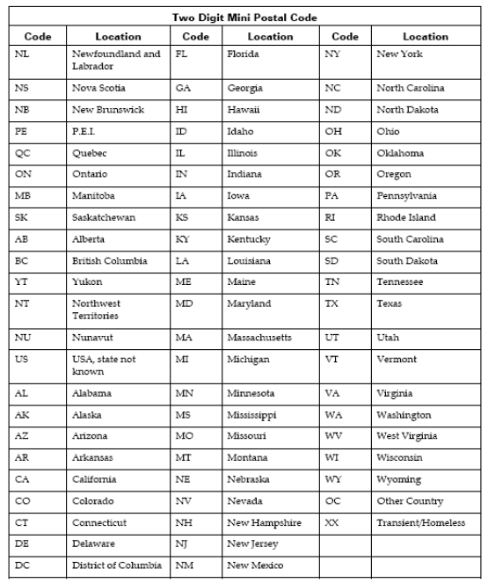

# Appendix 4: SCT Disease Indication Classification[3]

(Source: Cancer Care Ontario's Data Book - 2012-2013, Appendix 12.1 - SCT Disease Indication Classification, at link https://www.cancercare.on.ca/ext/databook/db1213/databook.htm).

|  |  |
| --- | --- |
| **Name** | **Description** |
| AML /APL | Acute Myeloid Leukemia (including Acute promyelocytic leukemia (APL)) |
| ALL | Acute Lymphoblastic Leukemia  (including lymphoblastic lymphoma) |
| AcuteLeukemiaOther | Acute leukemia other |
| CML | Chronic Myeloid Leukemia |
| CLL | Chronic Lymphocytic Leukemia |
| MDS/MPD | Myelodysplastic / Myeloproliferative Disease |
| MM | Multiple Myeloma |
| Amyloidosis | Amyloidosis |
| NHL | Non-Hodgkin's Lymphoma |
| HL | Hodgkin's Lymphoma |
| SAA | Severe aplastic anemia |
| Solid-Sarcoma | Solid tumours - Sarcoma |
| Solid-GermCell | Solid tumours - Germ cell tumours |
| Solid-Other | Solid tumours - Other |
| Other | Transplant indication not listed above |

# Appendix 5: MOHLTC Master Numbering System[4]

The Master Numbering System has been developed for the purpose of bringing together all Health Facilities and Programs under one system of identification. The list is a composite of health and health related units, facilities, clinics, programs and services. Each such organization has been assigned a unique four digit identifying code.

(For details, please refer Cancer Care Ontario's Data Book - 2012-2013, Appendix A: MOHLTC Master Numbering System, at link <https://www.cancercare.on.ca/ext/databook/db1213/documents/Appendix/CCO_Appendix_A_APR_12.pdf>).

# Appendix 6: Reason Patient Did Not Proceed[5]

* Disease Related
* Donor Unavailability
* Inadequate Stem Cell Yield
* Patient Comorbidity
* Patient Preference
* Treatment Toxicity
* Other

1. Appendix 3 on databook
2. Appendix 11 on databook
3. Appendix 12b on databook
4. Appendix 13 on databook
5. Appendix 26 on databook